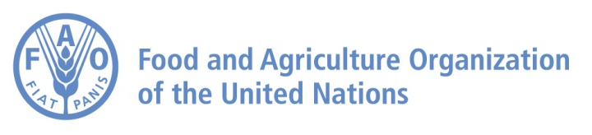

National Technical Meeting in Azerbaijan
Enhancing analytical evidence on diet and nutrition challenges from food systems perspectives
26 DECEMBER 2023
Baku, Azerbaijan
Online https://fao.zoom.us/xxxxx (tbc)

ABOUT THE PROJECT
FAO Regional Technical Cooperation Programme (TCP) TCP/RER/3805 – “Enhancing analytical evidence on diet and nutrition challenges from food systems perspectives” FAO-CAPNUTRA LoA “Food system analysis and capacity development on food based dietary guidelines in five selected countries in Europe and Central Asia” under the framework of the regional project aims to support Azerbaijan, Kyrgyzstan, Montenegro, Serbia and Uzbekistan in enhancing analytical evidence on diet and nutrition challenges from food systems perspectives, including those for developing national food systems based dietary guidelines (FSBDGs).

OBJECTIVES OF THE MEETING
- Present the potential of FSBDGs and its development methodology
- Present the results of applying FAO methodology on the FSBDG development
- Present and review the food system assessments and the situation analysis review report

AGENDA
TIME (Baku time, GMT+4) | ACTIVITY | SPEAKER
13.00-13.20 | Opening remarks  Moderator: Namig Shalbuzov | Zaur Aliyev, Adviser to the Minister, Ministry of Agriculture of the Republic of Azerbaijan, Azerbaijan, Baku  Bariz Mehdiyev, Assistant FAOR, FAO Partnership and Liaison Office in Azerbaijan, Azerbaijan, Baku (tbc)
13.20-13:40 | Introduction: Food system analysis and  food system based dietary guidelines  in Europe and Central Asia | Keigo Obara, Food Security Officer, FAO Sub-regional Office for Central Asia, Ankara, Türkiye  Mirjana Gurinovic, International Expert for Sustainable Food systems and Healthy Diets, Serbia, CAPNUTRA
13.40-14:00  14:00-14:10 | Potential of Food System Based Dietary Guidelines and its development methodology developed by FAO  Q&A | Ana Islas Ramos, FAO Nutrition Officer  Nutrition Education and Consumer  Awareness Group, Nutrition and Food Systems Division, Food and Agriculture Organization of the United Nations (FAO), Rome Italy (tbc)
14.10-14:30  14:30-14:40 | Development of Food System Based Dietary Guidelines in Montenegro  Q&A | Aleksandra Martinovic, FAO National Consultant on Nutrition (tbc)
14:40-14:50 | Break
14.40-15:00  15:00-15:10 | Capacity development in nutrition for creation of the national food system-based dietary guidelines FSBDGs in Balkan region  Q&A | Mirjana Gurinovic, International Expert for Sustainable Food systems and Healthy Diets, Serbia, CAPNUTRA
15:10-15:30  15:30-15:40 | Food system assessments and the situation analysis review report for Azerbaijan (draft)  Q&A | Keigo Obara, Food Security Officer, FAO Sub-regional Office for Central Asia, Ankara, Türkiye
16.40-17.00 | Discussion: Relevance and capacity development needs for developing FSBDGs in Azerbaijan  Moderator: Namig Shalbuzov | All participants
17.00 | Closing
NOTES
- A simultaneous translation will be provided for English and Uzbek throughout the meeting.
- All materials used for the presentations will be shared with participants after the meeting.

